**Date: 08-05-2025**

**INTERNSHIP LETTER**

This is to certify that **Mr. Thandra Sai Teja** was working in our organization

**Ozrit Ai Solutions** as **“Front End Developer”** from **06-02-2025 to 06-05-2025**

We hereby certify that his performance was good during the tenure.

His contribution to the organization and its success will always be appreciated.

We wish him all the best in his future endeavors.

**For Ozrit Ai Solutions.**

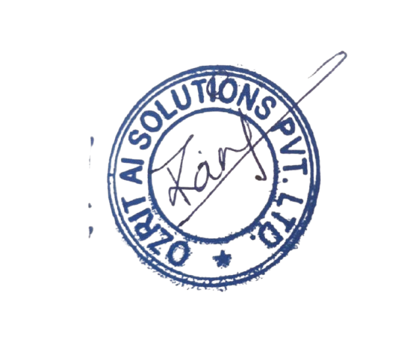

**Rani Kumari**

**HR & Admin Executive**